 | Testing and Training Center of Farm Machinery  Department of Farm Machinery and Power Engineering  College of Agricultural Engineering and Technology  Junagadh Agricultural University  JUNAGADH – 362 001 (GUJARAT) | 
P | Phone : (0285) 2672080-90, Ext. 390 & 484; Fax : (0285) 2671018

SPECIFICATION SHEET OF TRACTOR OPERATED MOBILE SHREDDER

1.0 | General
 | Name
 | Type
 | Make
 | Serial Number
 | Model
 | Year of manufacture
 | Name and address of manufacture
 | Source of power
 | Selling price in India
 | Recommended power of tractor, if tractor operated
 | Suitability
2.0 | Constructional Details
2.1 | Base frame:
 | a) |  |  |  |  | Type and material
 | b) |  |  |  |  | Size (mm)
2.2 | Cutting and Feeding assembly:
2.2.1 | Cutting disc
 | a) |  |  |  |  | Material and construction
 | b) |  |  |  |  | Size (mm)
 | c) |  |  |  |  | Method of mounting
 | d) |  |  |  |  | Method of power transmission
 | e) |  |  |  |  | Speed (rpm) corresponding to 540 rpm of the prime-mover:
2.2.2 | Feeding assembly:
 | a) |  |  |  | Type of feeding
 | b) |  |  |  | Material
 | c) |  |  |  | Height of feeding
 | d) |  |  |  | Width of feeding through shoes
 | e) |  |  |  | Method of mounting
2.2.2.1 |  |  |  | Feed rollers:
 |  |  |  | a) |  |  |  | Number of rollers
 |  |  |  | b) |  |  |  | Type
 |  |  |  | c) |  |  |  | Material
 |  |  |  | d) |  |  |  | Roller:
 |  |  |  |  |  |  |  | -Width and diameter of roller (mm)
 |  |  |  |  |  |  |  | -Effective width of roller (mm)
 |  |  |  |  |  |  |  | -No. of teeth on each roller and their configuration
 |  |  |  |  |  |  |  | -Type of teeth and pitch (mm)
 |  |  |  |  |  |  |  | -Size of teeth (mm)
 |  |  |  |  |  |  |  | -Type of roller shaft
 |  |  |  |  |  |  |  | -Size of roller shaft (mm)
 |  |  |  |  |  |  |  | -Number and type of shaft bearing
 |  |  |  |  |  |  |  | -Provision of lubrication
 |  |  |  | e) |  |  |  | Space between the axis of front and rear roller (mm):
 |  |  |  |  |  |  |  | Front-front
 |  |  |  |  |  |  |  | Front-rear
 |  |  |  | f) |  |  |  | Method of power transmission
 |  |  |  | g) |  |  |  | Speed (rpm) of feeding rollers corresponding to 540 rpm of the prime-mover:
2.2.2.2 |  |  |  | Main shaft:
 |  |  |  | a) |  |  |  | Material
 |  |  |  | b) |  |  |  | Length of shaft (mm)
 |  |  |  | c) |  |  |  | Diameter of shaft (mm)
 |  |  |  | d) |  |  |  | No. and types of bearings
 |  |  |  | e) |  |  |  | Method of shaft mounting
 |  |  |  | f) |  |  |  | Method of lubrication
2.2.2.3 |  |  |  | Gear box:
 |  |  |  | a) |  |  |  | Constructional details
 |  |  |  | b) |  |  |  | Type
 |  |  |  | c) |  |  |  | Method of power transmission
2.3 |  |  | Shredding mechanism:
2.3.1 |  |  | Fly Wheel:
 |  |  | a) |  |  |  |  | Constructional details
 |  |  | b) |  |  |  |  | Diameter of flywheel (mm)
 |  |  | c) |  |  |  |  | Thickness of flywheel (mm)
 |  |  | d) |  |  |  |  | Size of central bush (mm)
 |  |  | f) |  |  |  |  | No. and size of holes on the fly wheel for blade mounting (mm)
 |  |  | g) |  |  |  |  | Mass of flywheel (kg)
2.3.2 |  |  | Shredding Blades:
 |  |  | a) |  |  |  |  | Type
 |  |  | b) |  |  |  |  | Rotating blades
 |  |  |  |  |  |  |  | -Number of blades
 |  |  |  |  |  |  |  | -Material of blades
 |  |  |  |  |  |  |  | -Dimension of blade (mm)
 |  |  |  |  |  |  |  | -Method of mounting
 |  |  | c) |  |  |  |  | Fixed Blades
 |  |  |  |  |  |  |  | -Number of blades
 |  |  |  |  |  |  |  | -Size (mm)
 |  |  |  |  |  |  |  | -Method of mounting
2.4 |  |  | Main Power Transmission:
 |  |  | a) |  |  |  | Type
 |  |  | b) |  |  |  | Material and size (mm) of PTO pulley
 |  |  | c) |  |  |  | Size of flywheel pulley (mm)
 |  |  | d) |  |  |  | Type and size of belt
 |  |  | e) |  |  |  | Speed ratio of PTO pulley to flywheel pulley
 |  |  | f) |  |  |  | Arrangement for belt tensioning
2.5 |  | Delivering / Spreading assembly
 |  |  | a) |  |  |  |  |  | Type and material
 |  |  | b) |  |  |  |  |  | Size (mm)

2.6 | Hydraulic assembly
 |  | a) | Type
 |  | b) | Travel height (mm)
2.7 |  | Transport wheel:
 |  | a) |  | No.
 |  | b) |  | Material
 |  | c) |  | Size
2.8 | Safety arrangements:
2.9 |  | Type of hitch and its details :
 |  | Type and material
 |  | Shape

Specification of Hitch Pyramid As per IS: 4468-1997 (Part-I)

Sr. | Dimension  (Refer Fig.1) | Description | Measurement
Upper Hitch attachments
1 | d₁ | Diameter of hitch pin hole
2 | b’₁ | Width between inner faces of yoke
3 | b’₂ | Width between outer faces of yoke
Lower hitch points
4 | D₂ | Dia. of hitch pin
5 | b’₃ | Linch pin hole distance
6 | l | Lower hitch point span
Other dimensions
 | Diameter of linch pin hole
7 | d | For upper hitch pin
8 |  | For lower hitch pin
9 | h | Mast height

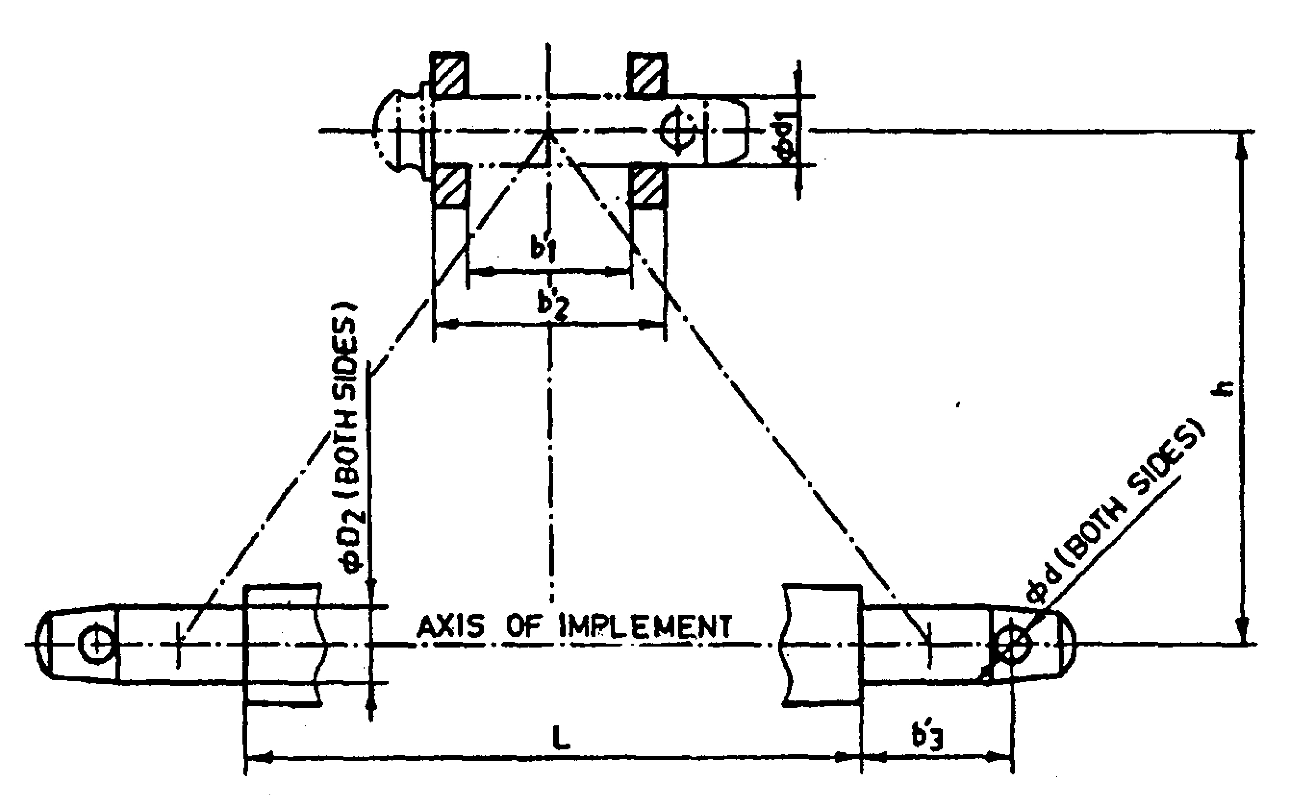
Fig. 1 : Implement Hitch Attachment

2.10 | Splined end of shredder input shaft (Ref. Fig.2 ):
Dimension of Implement Power Input Shaft As per IS: 4931-2006

Sr. | Specification/ Notations  (Refer Fig.5) | Dimensions
1 | PTO Type 1/2/3
2 | Nominal speed (rpm)
3 | Nominal dia.(mm)
4 | Number and type of splines
Dimensions (mm)
5 | D Φ
6 | d Φ
7 | B Φ
8 | A Φ
9 | W
10 | a
11 | b
12 | c
13 | x
14 | B

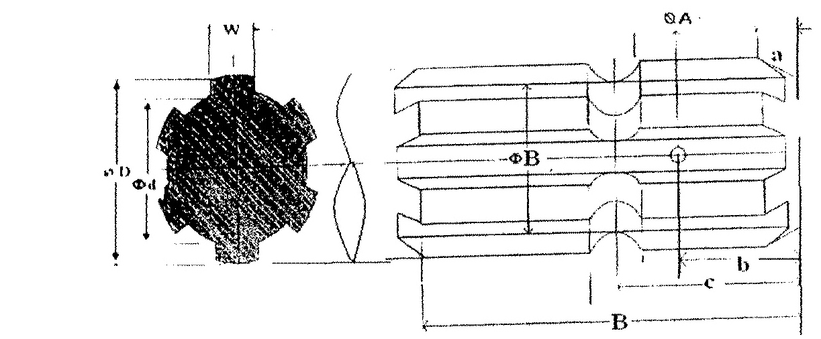
Fig. 2 Dimension of Implement Power Input Shaft
2.11 | Propeller shaft:
 | a) | Type and material
 | b) | Length of shaft (mm)
 |  | Minimum
 |  | Maximum
 | c) | Mass of shaft (kg)
 | d) | Provision for locking

Propeller Shaft Insert Dimensions As per IS: 4931-1995

Sr. | Notations  (Refer Fig.3)
1 | D Φ
2 | d Φ
3 | W
4 | B
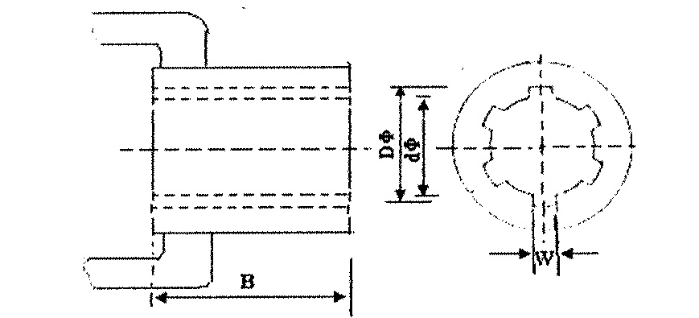
Fig. 3 : Propeller Shaft Insert Dimensions

2.12 | Overall Dimensions (mm)
 | a) | Length
 | b) | Width
 | c) | Height
 | d) | Mass, (kg)

Place: Date:
Signature : _________________________ Name : _________________________

Designation: ________________________

